1. Layers 2, 3, 4, 5

Layer 2 (Ethernet Frame)

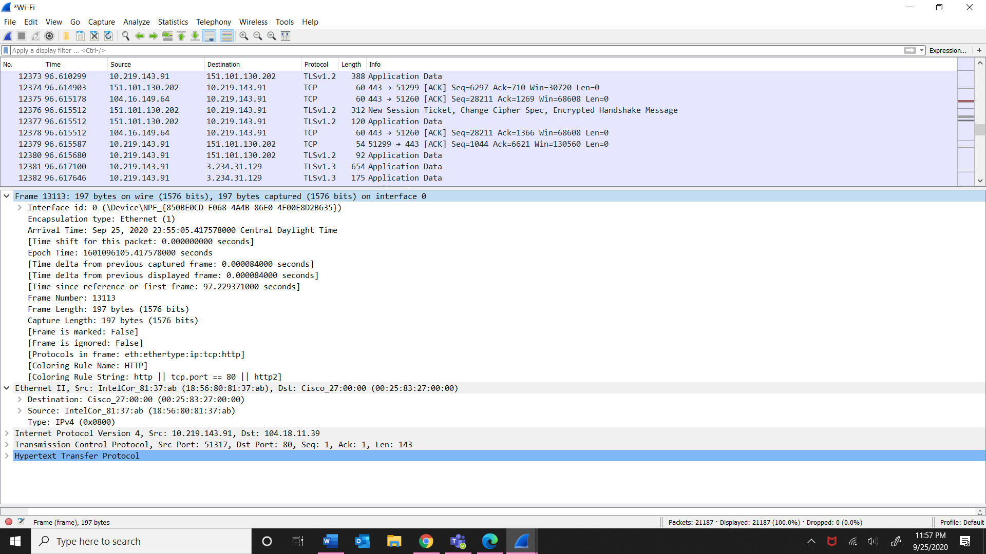

Layer 3 (IP packets)

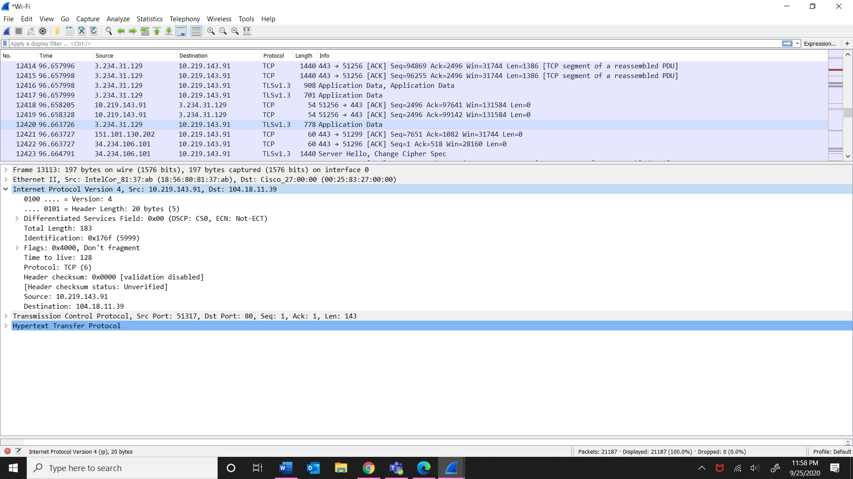

Layer 4 (TCP segment)

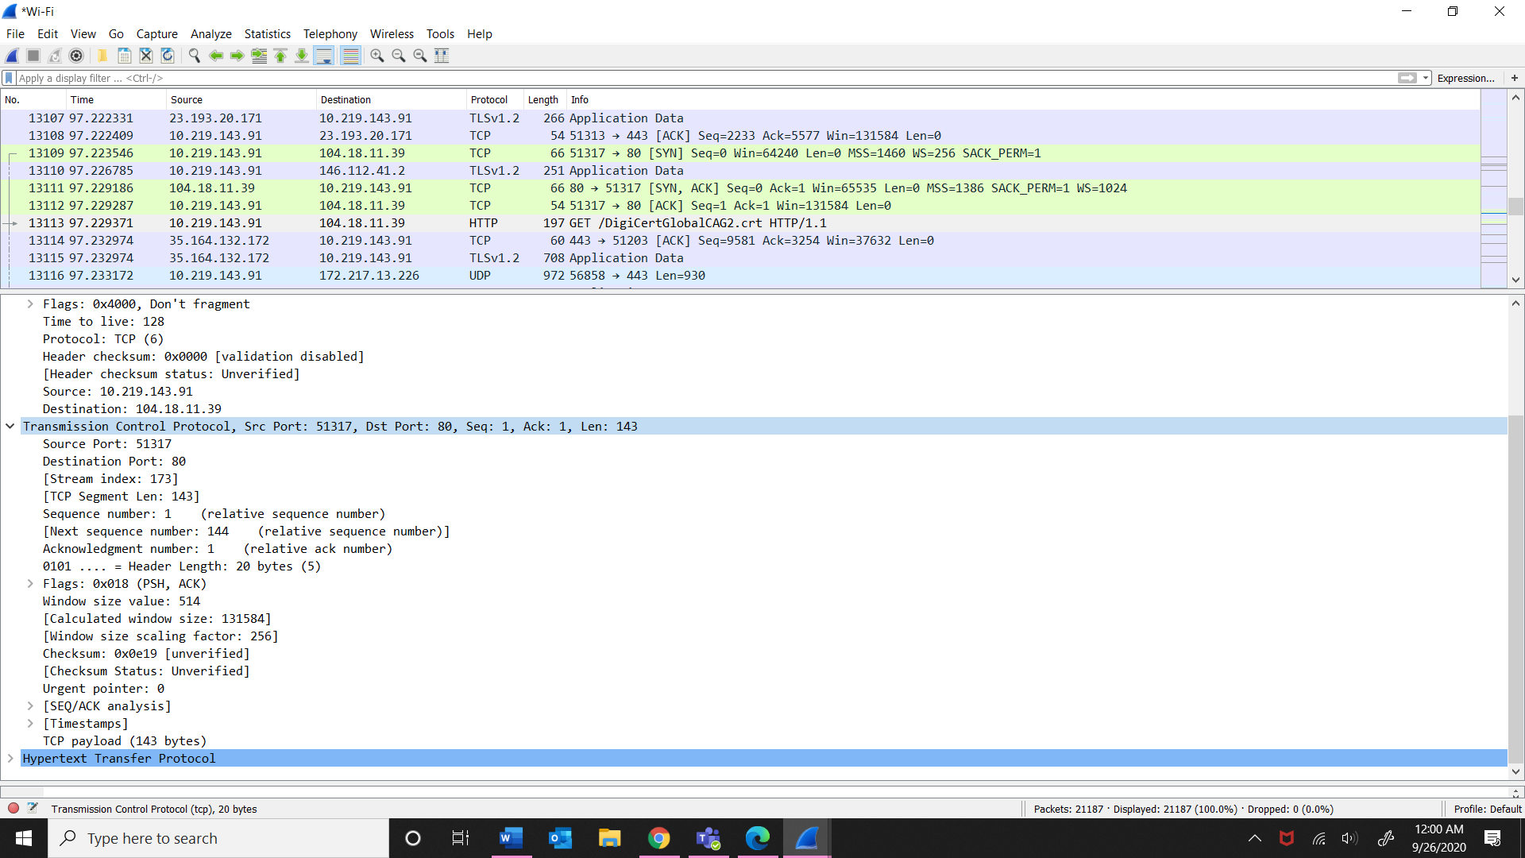

Layer 5 (HTTP)

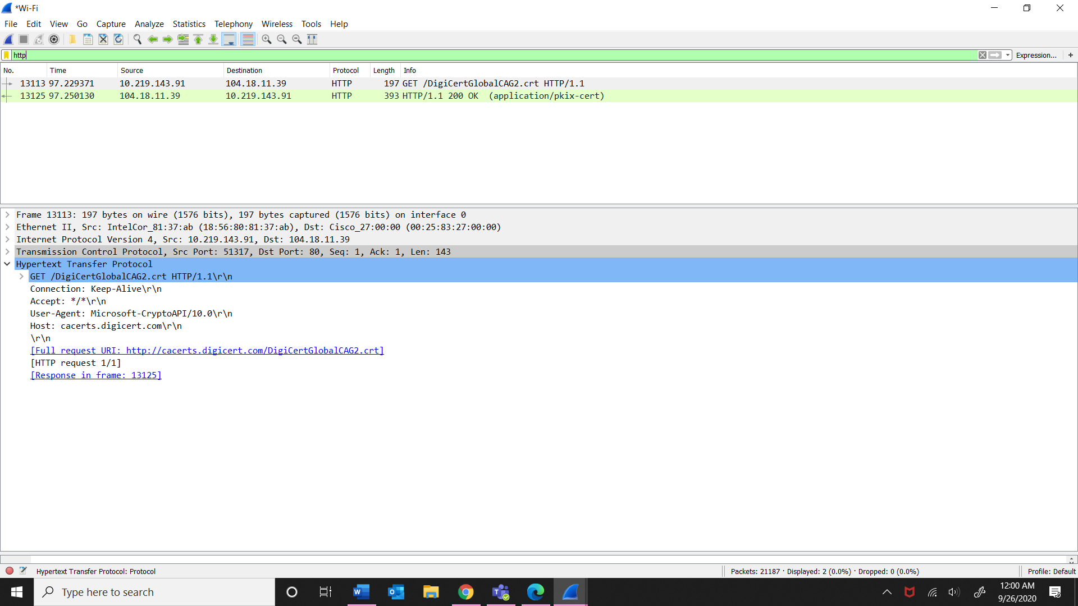

1. Source: IntelCol_81:37: ab

Destination: Cisco_27:00:00 (00:25:83: 27:00:00)

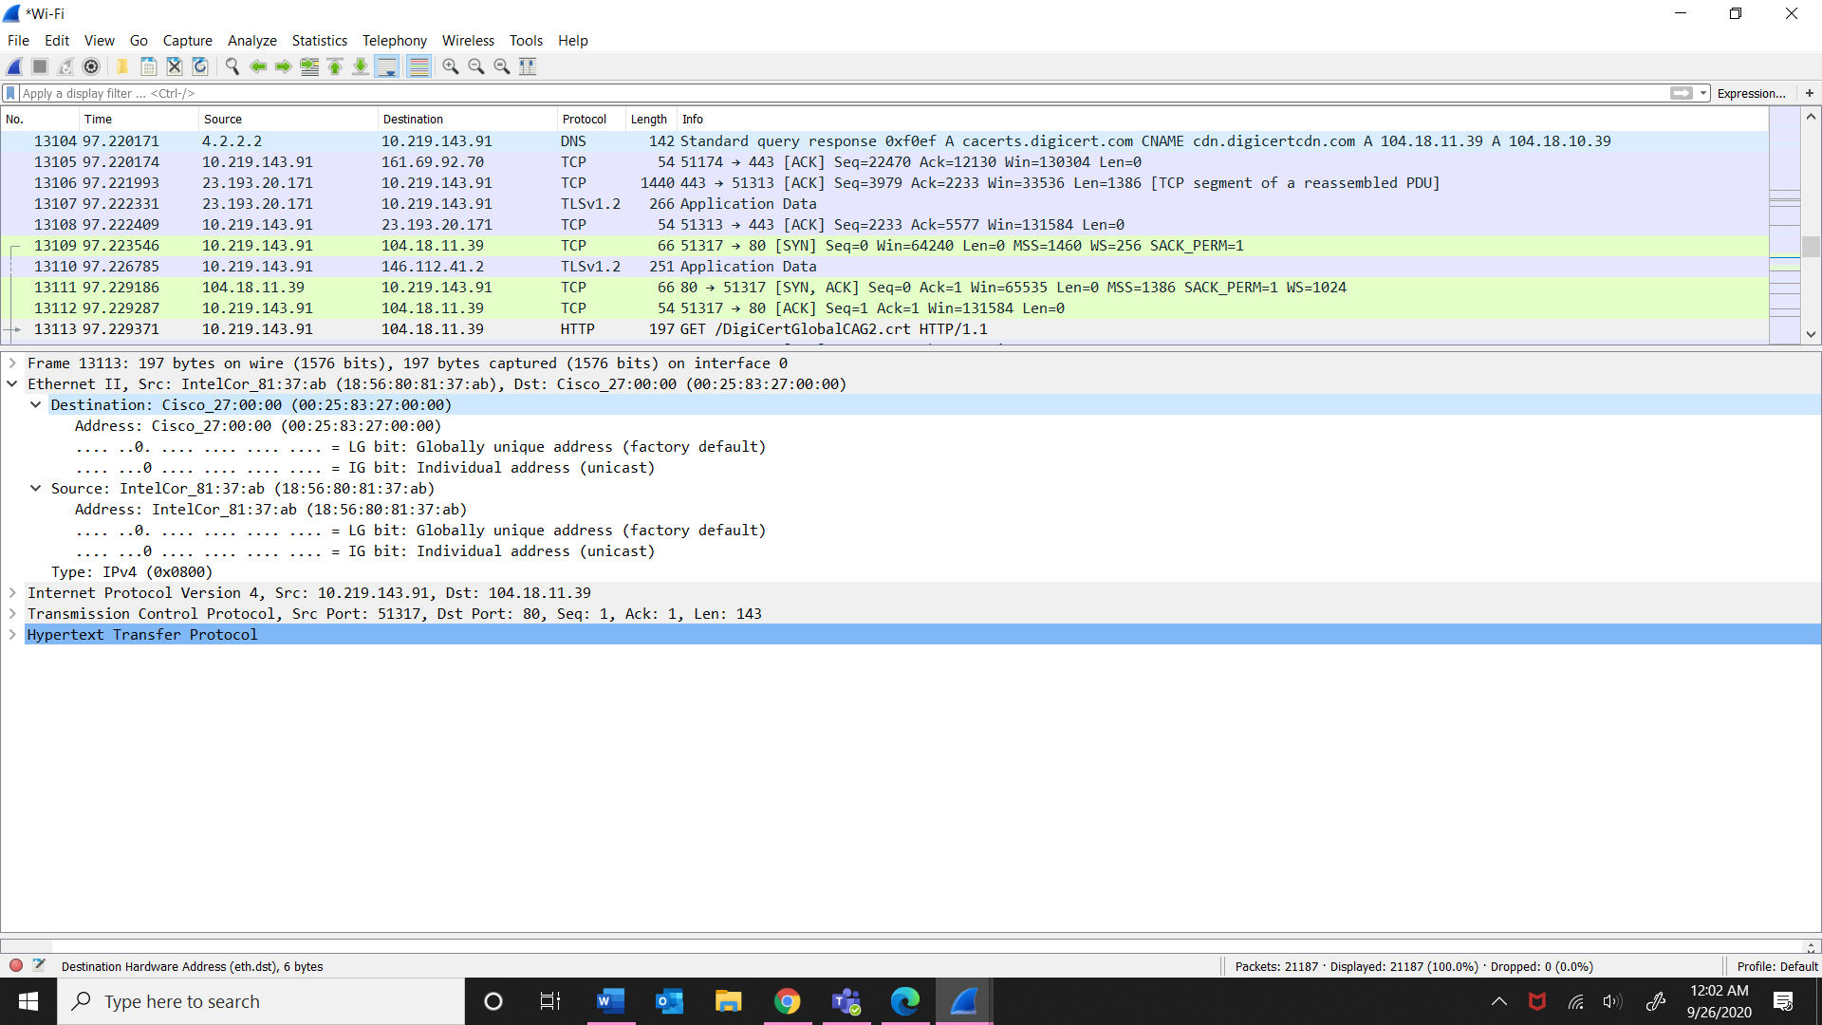

1. It uses IPv4 because it is widely used protocol for data communication and is responsible for providing logical connections between network devices.

